

**Faculty of Science and Technology**

**COM 122 – Principles of Programming in C**

**Date:** 6th December 2023 **Time:** 3 hrs.

**Time allowed:** 2:00pm - 5:00pm

**INSTRUCTIONS TO CANDIDATES**

* This paper contains two parts: Section A and Section B.
* Section A is case study based or non - case study based and is **COMPULSARY**. Half the total marks will be gained on Section A and the other half from Section B which contains 4 questions.
* Candidates must attempt **TWO** questions only from Section B.
* Write your solutions in the paper provided.
* For **ONLINE (DL)** candidates, write your solutions in a paper and submit in the Pictures or Scanned copies of the paper in **SOFT** form for Marking.
* Typed work will **NOT** be considered for marking.
* Any work detected to be from **ChatGPT 3.5** or any **OpenAI** will **NOT** be awarded marks.

**Section A**

Answer Both Questions

A student taking principle of programming in C at Cavendish University, wrote and compiled the following codes online with output as seen in the Figure. Use it to answer Question 1 and 2.

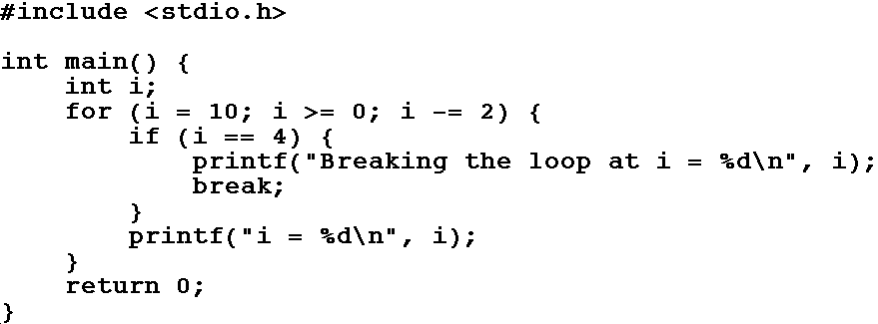

**Q.1.**

**a)** Record the outputs of these codes? **(5 marks)**

b) You are required to write codes to produce the same output using:

1. While loop **( 10 marks)**
2. Do while loop **(10 marks)**

**Q.2.**

Improve the codes in the figure above to produce these outputs: **(25 marks)**

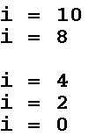

**Total 25 Marks**

**Section B**

Answer **two** Questions

**Q.3.**

The following function is specified to return the quotient of two integers, returning zero when the answer is undefined.

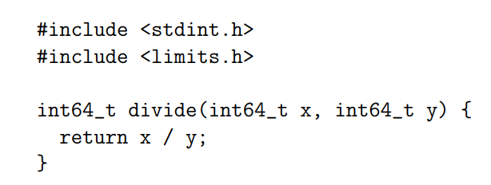

1. What are bugs in a program? **(5 marks)**
2. Identify two bugs in this program **(10 marks)**
3. Write a correct version of this program. **(10 marks)**

**Total 25 Marks**

**Q.4.**

Study the codes below and Rewrite the codes to produce the products of two numbers:

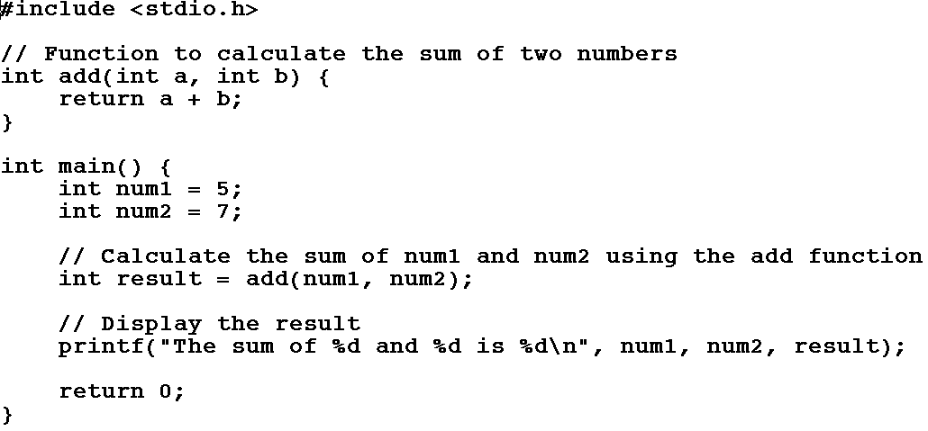

**Total 25 Marks**

**Q.5.**

Consider the code:



1. Write a pointer **‘p’** that points to the first element in the array. **(5 marks)**
2. Write a pointer that retrieves the third element using pointer arithmetic. **(5 marks)**
3. Write a pointer that retrieves the last element using pointer arithmetic. **(5 marks)**
4. Write a pointer that retrieves the middle element using pointer arithmetic. **(5 marks)**
5. Explain Static and Dynamic Memory Allocation. **(5 marks)**

**Total 25 Marks**

**Q.6.**

Consider expressions represented using the following ML datatype:

**datatype exp = Var of string | Neg of exp | Divide of exp * exp**

1. Using at least one union, define a type or types in the C language for conveniently storing such expressions. **(5 marks)**
2. Give efficient C code that checks whether two structures represent identical expressions. (Do not consider whether they might evaluate to the same result.) Explain how much of the input expressions is explored when they differ. **(4 marks)**
3. Given that a lot of expressions are to be rapidly generated and discarded, what considerations apply to storage management? Define and discuss at least 3 different approaches to storage management**. (5 marks)**
4. The substitution operation for an expression replaces all occurrences of one variable with another variable.
   1. Given that sub-expression trees are commonly shared over numerous expressions, explain a problem that could arise in the substitution operation. **(5 marks)**
   2. Explain the details of a solution to the problem by giving code or otherwise. **(6 marks)**

**Total 25 Marks**